Did you know….

- Stress is the #1 factor mostly likely to affect your academic studies.
- Stress can be prevented and decreased with a few simple steps.

To Prevent Stress…
- Get organized. Buy and use a daily planner. Start and complete assignments/tasks early rather than waiting till the last minute.
- Change your perspective. In the whole scheme of things, is it really that important to get worked up over? Yes, the test/paper/presentation is important, but it’s also ONLY ONE part of your entire college experience.
- Exercise! Exercise! Exercise! This is the best way to relieve stress, burn extra calories and make you feel good. With so many benefits, make exercising a daily priority.

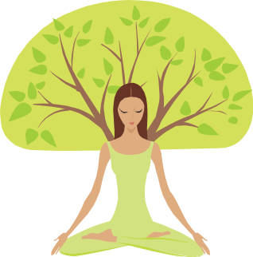
20 Healthy Ways to Relieve Stress

- Listen to music. Classical or Enya are soothing.
- Get a Massage
- Read inspirational quotes, poems or letters.
- Unplug. Turn off cell phone, TV, computer, etc. and enjoy the quiet moments
- Laugh.
- Read a good book.
- Volunteer.
- Make a list of goals, dreams, wishes, etc.
- Pet a pet. Animals are great stress relievers.
- Give a friend or loved one a hug.
- Practice Mindfulness.
- Get creative. Color, draw, write, etc.
- Practice visualization.
- Take a break. Go for a walk, stretch, get out of your environment for a bit.
- Nourish your body. Eat healthy (fruits and veggies) and avoid caffeine/high fat/calories foods.
- Get some rest. Try to get 8 hours of sleep a night or close to it.
- Stop negative thoughts/criticisms and replace with a positive mantra. Ex. I love my curly hair it reminds me of my mother’s hair.
- Exercise Daily!
- Don’t be a perfectionist and don’t have a type A personality.
- Get organized and don’t procrastinate.
Signs and Symptoms of stress

Anxious Irritable Moody Sad

Problems Sleeping Problems Eating

Negative Thoughts Anxiety

Neck Aches Back Aches

Stomach Distress

Difficulty Concentrating

Decreased Attention Span

Poor Memory Teeth Clenching

Increased Alcohol or Drug Use

Quiz: Is stress putting your health at risk?

Everyone reacts to stress differently. What overwhelms one person may be a motivating challenge to another. It’s not the situation that can affect your health; it’s how you perceive it. To see if your reactions can compromise your health, take the quiz.
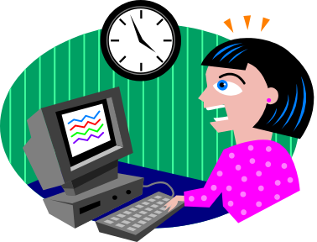

Yes No

__ __ 1. I get lots of tension headaches.
__ __ 2. I often breathe faster and my heart “races”.
__ __ 3. I clench my jaw or grind my teeth.
__ __ 4. I routinely “feel” stressed.
__ __ 5. I tend to suffer from gastrointestinal symptoms such as diarrhea.
__ __ 6. I often experience muscle tension (hunched shoulder or a stiff neck.
__ __ 7. I often feel nervous or jittery.
__ __ 8. I perspire a lot, or get chills and clammy hands.
__ __ 9. I easily become upset, angry, irritable or impatient.

Scoring

Some of these answers could indicate other medical problems, but if you answered yes to more than three of them, it may mean that you react to stress in harmful ways. You need to learn coping skills and long term relaxation techniques. For immediate stress relief, sit quietly, taking slow deep breaths. Relax your shoulders and jaw; visualize a peaceful place, or listen to calming music. Concentrate on changing your mind-set too: If you’re worried about an upcoming exam, remind yourself that you almost always do fine.

Source: Shape Your Life, by Barbara Harris and Angela Hynes, Copyright by The Philip Lief Group, Inc., and Weider Publications, Inc., 2003.
For more information about how to prevent or relieve stress contact

The Health and Wellness Office at wellness@stonehill.edu or stop by in person!

We’re located in the Roche Dining Commons, Room 113.
How to Reduce Stress:
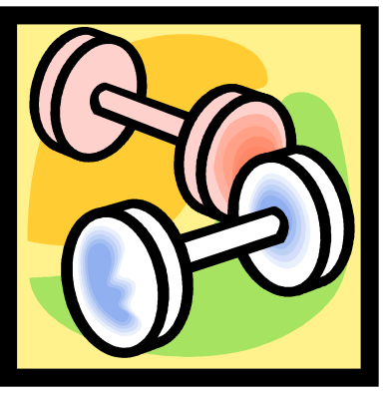

- Exercise
- Get a massage
- Take a break
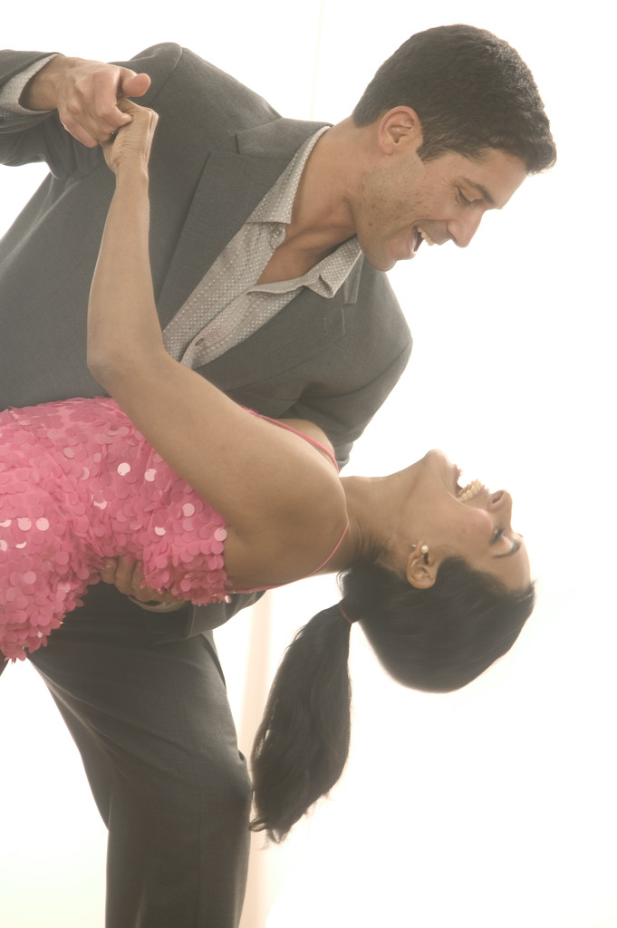
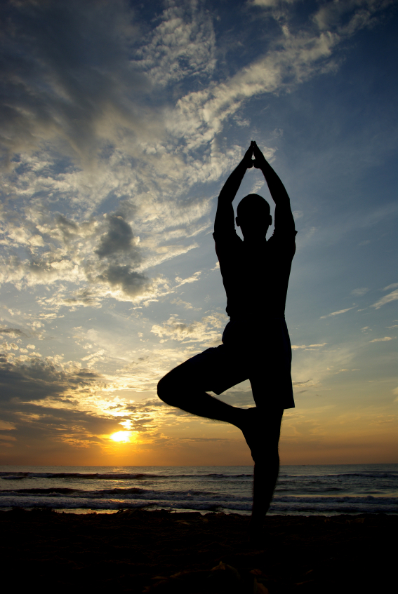
- Laugh
- Dance
- Have fun
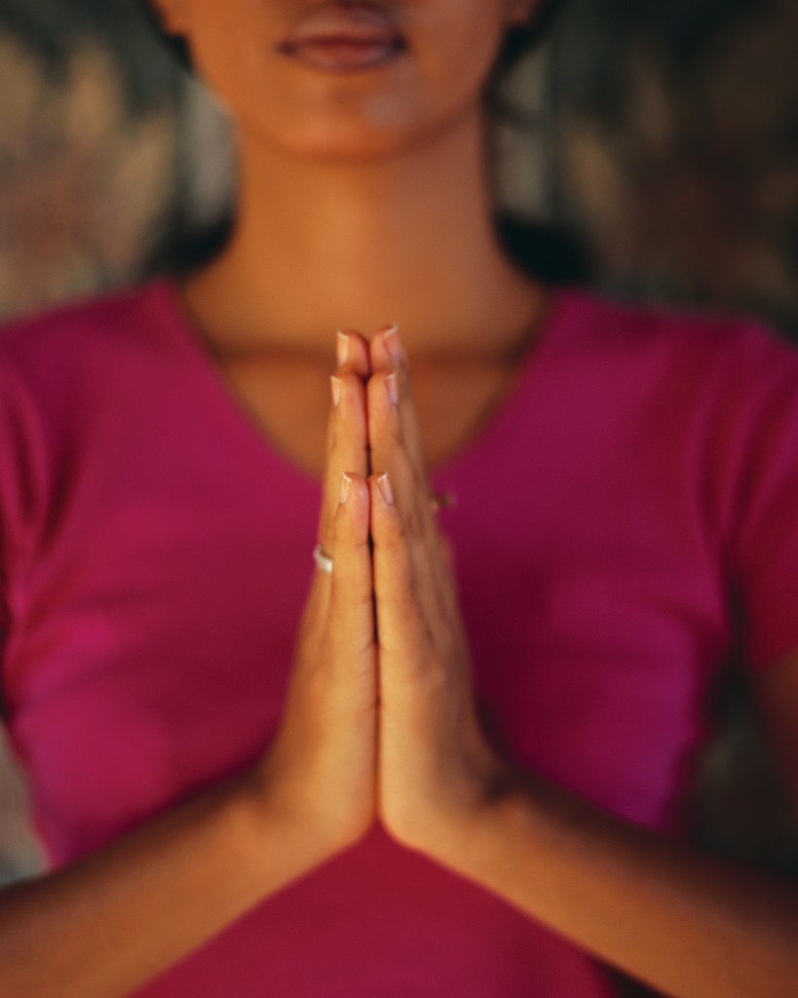

- Talk to a friend
- Watch a movie
- Take a bath
- Tell a joke

- Have a cup of tea

- Pray
- Meditate
- Practice Yoga
- Practice deep breathing
- SMILE! ☺

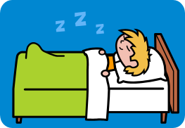
Jacobson’s Progressive Relaxation

- Lie on your back or sit in a comfortable chair. Lift both hands slightly and make tight fists. Feel the tension and notice it carefully. Now release the fists and let the tension slide all away. Feel the difference, noticing the pleasant warmth of relaxation. Repeat this sequence again with the hands, but use only about half the tension. Repeat again for a third time, tensing the hand, but allowing little movement this time so that only slight tension can be detected.
- Lift your arms at shoulders and tense (contract) all muscles in the arms. Feel the tension, noticing it carefully. Now release the arms and let the tension slide all away. Feel the difference, noticing the pleasant warmth of relaxation. Repeat this sequence again with the arms, bus use only about half the tension. Repeat the sequence for a third time, but allow little movement so that only slight tension can be detected.
- Shrug your shoulders and hold until you locate the tension there. Feel the tension, noticing it carefully. Now release the shoulders and let the tension slide away. Again feel the difference between the tension and relaxation. Repeat this shoulder shrug with about half the tension, relax, and notice the difference. Repeat the shrug for a third time with only a slight bit of tension, and then relax.

For muscle groups of the lower limps, trunk and face it is only necessary to tense the muscles once, very slightly, just enough to recognize the tension. Then let it slide away. Feel the difference. Notice the pleasant warmth of relaxation. Tense and relax the rest of the muscles (of the lower limbs, trunk and face) in the following sequence:

- Feet: Bend or extend toes, relax; lift toes, relax.
- Legs: Start to bend knees (drag heels up slightly); relax.
- Buttocks: Squeeze them together; relax.
- Abdomen: Make abdomen tight and hard; relax.
- Chest and neck: Squeeze shoulder blades together and slightly arch back, pressing head backward; relax.
- Breathing: Take a slow deep breath and relax completely as you exhale. Repeat two or three times.
- Upper face and scalp: Raise eyebrows; relax. Close eyes tightly; relax.
- Center face: Scowl and wrinkle nose; relax. Widen cheeks and brow; relax.
- Lower face: Purse lips; relax. Smile; relax. Drop jaw; relax.
- Breathing: Take a slow deep breath and relax completely as you exhale. Repeat two or three times.
- Tense all the muscles together and hold for five seconds.
- Feel the tension, notice it carefully, then release it. Let all the tension slide away.
- Notice any remaining tension. Release it.
- Take a deep breath. Say “Relax” softly to yourself as you breathe out slowly.
- Remain totally exhaled.
- Repeat breathing in and out slowly, saying “Relax”, staying perfectly relaxed. Do this three times.
- The exercise has ended. Enjoy the relaxation.

(Source: J. Fries and K. Lorig, The Arthritis Helpbook, Reading Massachusetts: Addision-Wesley, 1986.)

